**Updated ERD**

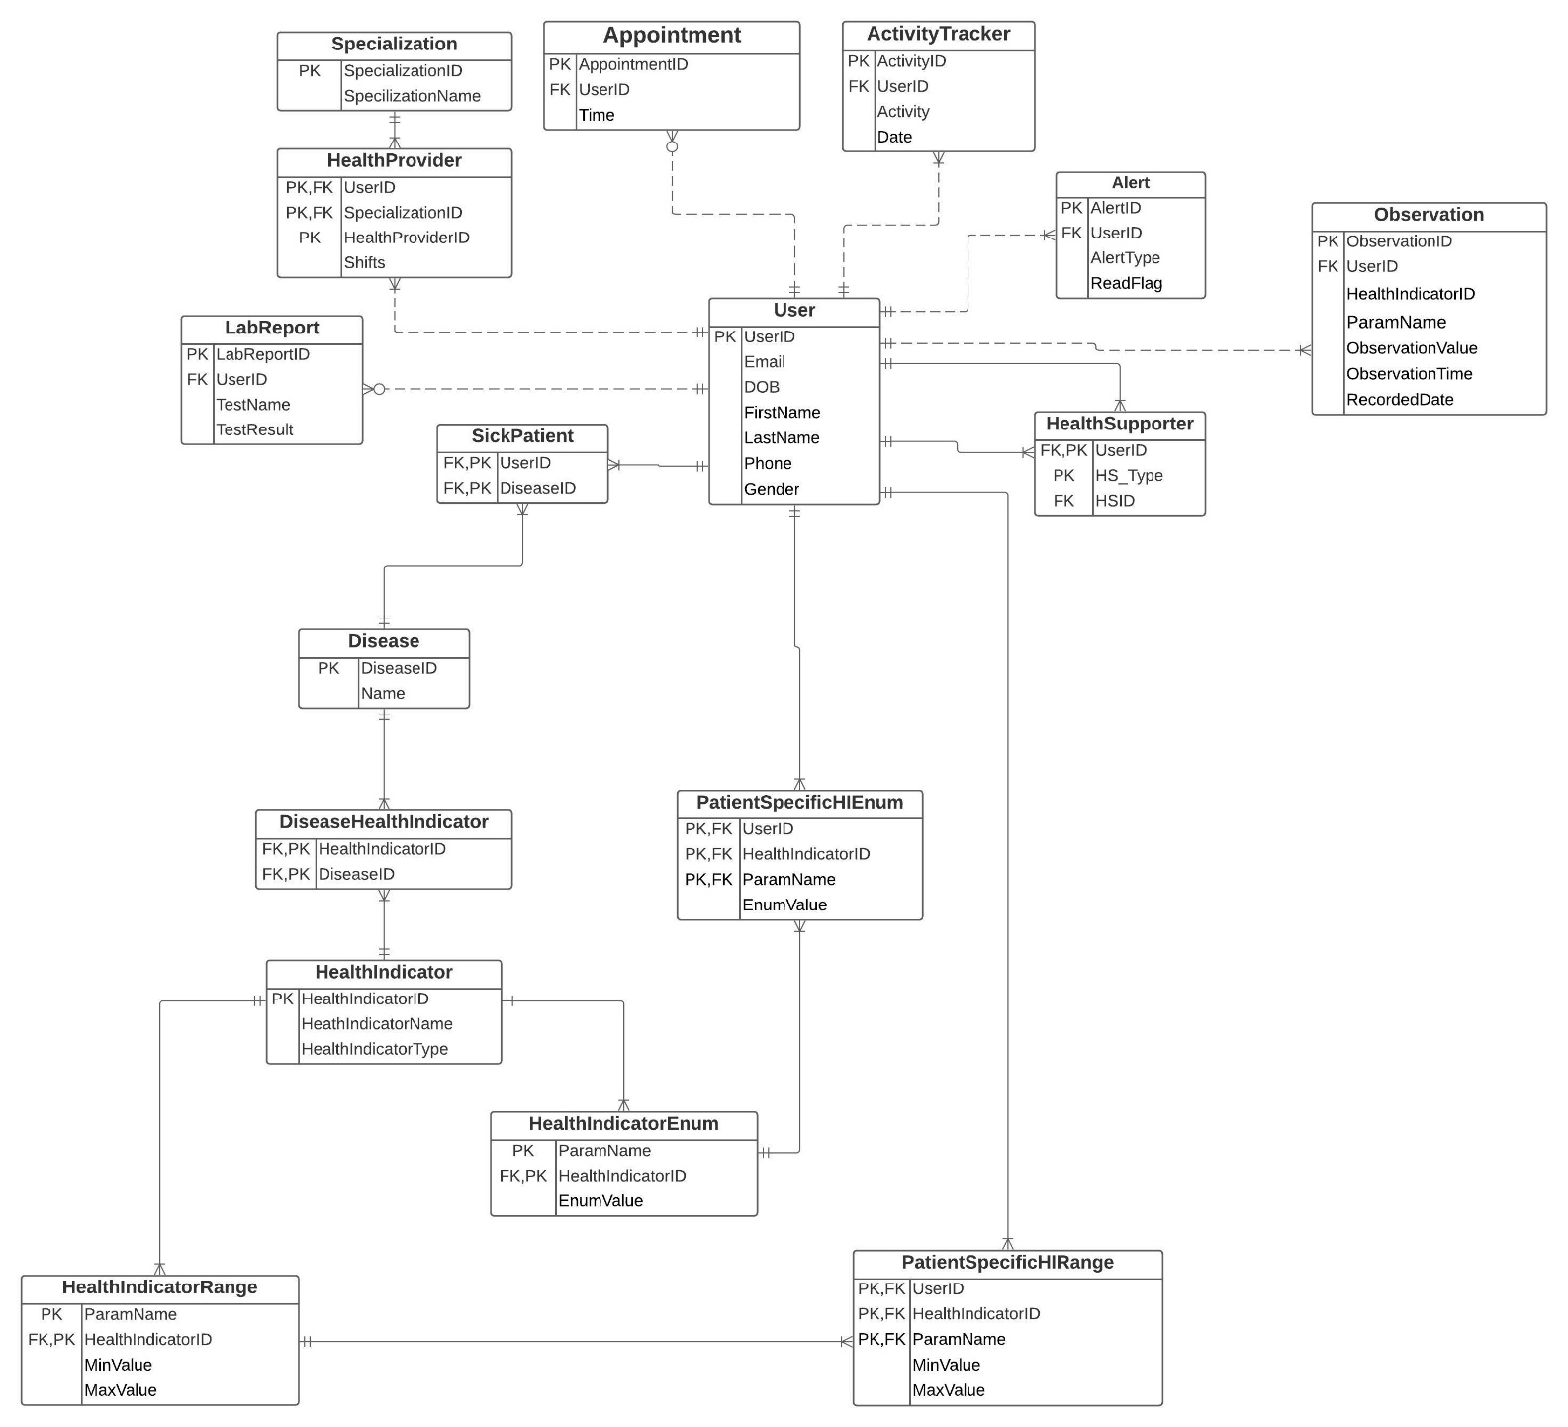

**Changes:**

|  |  |  |
| --- | --- | --- |
| **S No** | **CHANGES** | **REASON** |
| 1 | Rename Booking Appointment to Appointment Health Provider ID attribute removed | While booking appointment for User, HealthProviderID is not necessary |
| 2 | User Access Entity is removed | As we don't have any front-end implementation, User Access entity has been removed |
| 3 | Lab Report Entity - Reports(attr) updated to Test Name and Test Result | Creating meaningful attribute as TestName and TestResult instead of Report |
| 4 | Insurance Details Entity - Removed | Ignoring Insurance Entity, considering user makes payment at Hospital |
| 5 | HealthProvider Entity - UserId attr added and replace Specialization attr with SpecializationId | Modifying the relation to remove many to many relations and adding appropriate FK and PK attributes |
| 6 | Specialization Entity - Added | Helping user to consult specialized doctor in the Hospital |
| 8 | Observation - Removed FK constraint for Health IndicatorID | Removed constraint FK for HealthIndicatorID |
| 9 | HealthSupporter Entity - Added | Resolving many to many relations to identify health supporters for patients |
| 10 | Sick Patient Entity - Added | Resolving many to many relations between User and Disease |
| 11 | Disease Entity - HealthTipID removed | HealthTip Entity removed as it’s no longer required, hence removed the attribute HealthTipId from Disease |
| 12 | DiseaseHealthIndicator Entity - Added | DiseaseHealthIndicator Entity is added for resolving many to many relations between Health Indicator with Disease |
| 13 | HealthIndicatorRange | HealthIndicatorRange is used for HealthIndicators which can be represented using a range of values  Eg: Temperature: 97F-99F |
| 14 | HealthIndicatorEnum | HealthIndicatorEnum is used to describe HealthIndicators using enum values Eg: Mood: Happy, Sad, Angry, Dull |
| 15 | Rename HealthIndicatorRangePatientOverride to PatientSpecificHIRange | Entity Name updated for better readability |
| 16 | Rename PatientHIEnumValues_Override to PatientSpecificHIEnum | Entity Name updated for better readability |
| 17 | Change Formatting for Composite PK attributes | Each PK attribute in case of Composite PK has been moved to new row and has been labelled accordingly |
| 18 | User entity - Name attr | Name has been made atomic by adding FirstName and LastName |